Database Schema

* **RELATIONAL SCHEMA**

The database of the Card Maker Application has a schema of five tables:

**Cards (eventtype, recipient, orientation)**

**Elements (element_ID, eventtype, recipient, page)**

**TextElements (text_ID, left, top, width, height, font, text)**

**ImageElements (image_ID, s3ID, left, top, width, height)**

**s3pic (s3pic_ID, url)**

* **Entity-Relationship Diagram (ERD) (ER SCHEMA)**

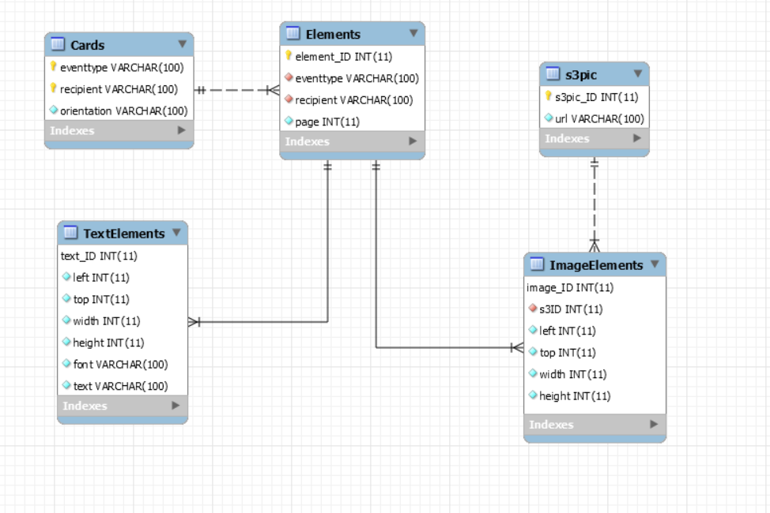

* **SQL CREATE TABLE STATEMENT**

CREATE TABLE `Cards` (

`eventtype` varchar(100) NOT NULL,

`recipient` varchar(100) NOT NULL,

`orientation` varchar(100) NOT NULL DEFAULT 'landscape',

PRIMARY KEY (`eventtype`,`recipient`)

);

CREATE TABLE `Elements` (

`element_ID` int(11) NOT NULL AUTO_INCREMENT,

`eventtype` varchar(100) NOT NULL,

`recipient` varchar(100) NOT NULL,

`page` int(11) NOT NULL,

PRIMARY KEY (`element_ID`),

KEY `fk_eventtype_idx` (`eventtype`,`recipient`),

CONSTRAINT `fk_card` FOREIGN KEY (`eventtype`, `recipient`) REFERENCES `Cards` (`eventtype`, `recipient`) ON DELETE NO ACTION ON UPDATE NO ACTION

);

CREATE TABLE `s3pic` (

`s3pic_ID` int(11) NOT NULL AUTO_INCREMENT,

`url` varchar(100) NOT NULL,

PRIMARY KEY (`s3pic_ID`)

) ;

CREATE TABLE `ImageElements` (

`image_ID` int(11) NOT NULL,

`s3ID` int(11) NOT NULL,

`left` int(11) NOT NULL,

`top` int(11) NOT NULL,

`width` int(11) NOT NULL,

`height` int(11) NOT NULL,

PRIMARY KEY (`image_ID`),

KEY `fk_s3_idx` (`s3ID`),

CONSTRAINT `fk_image` FOREIGN KEY (`image_ID`) REFERENCES `Elements` (`element_ID`) ON DELETE NO ACTION ON UPDATE NO ACTION,

CONSTRAINT `fk_s3` FOREIGN KEY (`s3ID`) REFERENCES `s3pic` (`s3pic_ID`) ON DELETE NO ACTION ON UPDATE NO ACTION

) ;

CREATE TABLE `TextElements` (

`text_ID` int(11) NOT NULL,

`left` int(11) NOT NULL,

`top` int(11) NOT NULL,

`width` int(11) NOT NULL,

`height` int(11) NOT NULL,

`font` varchar(100) NOT NULL,

`text` varchar(100) NOT NULL,

PRIMARY KEY (`text_ID`),

CONSTRAINT `fk_idtext` FOREIGN KEY (`text_ID`) REFERENCES `Elements` (`element_ID`) ON DELETE NO ACTION ON UPDATE NO ACTION

) ;